Paper Reference(s)
6674
Edexcel GCE
Pure Mathematics P4
Advanced/Advanced Subsidiary
Monday 20 January 2003 − Morning
Time: 1 hour 30 minutes

Materials required for examination Items included with question papers
Answer Book (AB16) Nil
Graph Paper (ASG2)
Mathematical Formulae (Lilac)

Candidates may use any calculator EXCEPT those with the facility for symbolic algebra, differentiation and/or integration. Thus candidates may NOT use calculators such as the Texas Instruments TI 89, TI 92, Casio CFX 9970G, Hewlett Packard HP 48G.

Instructions to Candidates
In the boxes on the answer book, write the name of the examining body (Edexcel), your centre number, candidate number, the unit title (Pure Mathematics P4), the paper reference (6674), your surname, initials and signature.
When a calculator is used, the answer should be given to an appropriate degree of accuracy.

Information for Candidates
A booklet ‘Mathematical Formulae and Statistical Tables’ is provided.
Full marks may be obtained for answers to ALL questions.
This paper has eight questions. Pages 6, 7 and 8 are blank.

Advice to Candidates
You must ensure that your answers to parts of questions are clearly labelled.
You must show sufficient working to make your methods clear to the Examiner. Answers
without working may gain no credit.

This publication may only be reproduced in accordance with Edexcel copyright policy.
Edexcel Foundation is a registered charity. ©2003 Edexcel

1. z = $4\left(\text{cos}\frac{π}{4}+i\text{sin}\frac{π}{4}\right)$, and w = $3\left(\text{cos}\frac{2π}{3}+i\text{sin}\frac{2π}{3}\right)$.

Express zw in the form r (cos θ + i sin θ ), r > 0, −π < θ < π.
(3)

2. (a) Sketch, on the same axes, the graphs with equation y = ⏐2x – 3⏐, and the line with equation y = 5x – 1.
(2)
(b) Solve the inequality ⏐2x – 3⏐ < 5x – 1.
(3)

3. (a) Express $\frac{2}{(r+1)(r+3)}$ in partial fractions.
(2)
(b) Hence prove that $\sum_{r=1}^{n}{\frac{2}{(r+1)(r+3)}≡\frac{n(5n+\text{13})}{6(n+2)(n+3)}}$.
(5)

4. f(x) = 2 sin 2x + x – 2.

The root α of the equation f(x) = 0 lies in the interval [2, π].

(a) Using the end points of this interval find, by linear interpolation, an approximation to α.
(4)
(b) Taking 2.8 as a first approximation to α, apply the Newton-Raphson procedure once to f(x) to find a second approximation to α, giving your answer to 3 significant figures.
(5)

5. (a) Use the substitution y = vx to transform the equation
$\frac{dy}{dx}$ = $\frac{(4x+y)(x+y)}{x^{2}}$, x > 0 (I)
into the equation
x$\frac{dv}{dx}$ = (2 + v)². (II)
(4)
(b) Solve the differential equation II to find v as a function of x.
(5)
(c) Hence show that
y = −2x − $\frac{x}{\text{ln}x+c}$, where c is an arbitrary constant,
is a general solution of the differential equation I.
(1)

6. Given that z = 3 – 3i express, in the form a + ib, where a and b are real numbers,

(a) z²,
(2)
(b) $\frac{1}{z}$.
(2)
(c) Find the exact value of each of ⏐z⏐,⏐z²⏐ and $\left|\frac{1}{z}\right|$.
(2)
The complex numbers z, z² and $\frac{1}{z}$ are represented by the points A, B and C respectively on an Argand diagram. The real number 1 is represented by the point D, and O is the origin.

(d) Show the points A, B, C and D on an Argand diagram.
(2)
(e) Prove that OAB is similar to OCD.
(3)

7. (a) Find the value of λ for which λx cos 3x is a particular integral of the differential equation
$\frac{d^{2}y}{{dx}^{2}}$+ 9y = −12 sin 3x.
(4)
(b) Hence find the general solution of this differential equation.
(4)

The particular solution of the differential equation for which y = 1 and $\frac{dy}{dx}$ = 2 at x = 0, is y = g(x).

(c) Find g(x).
(4)
(d) Sketch the graph of y = g(x), 0 ≤ x ≤ π.
(2)

8. Figure 1

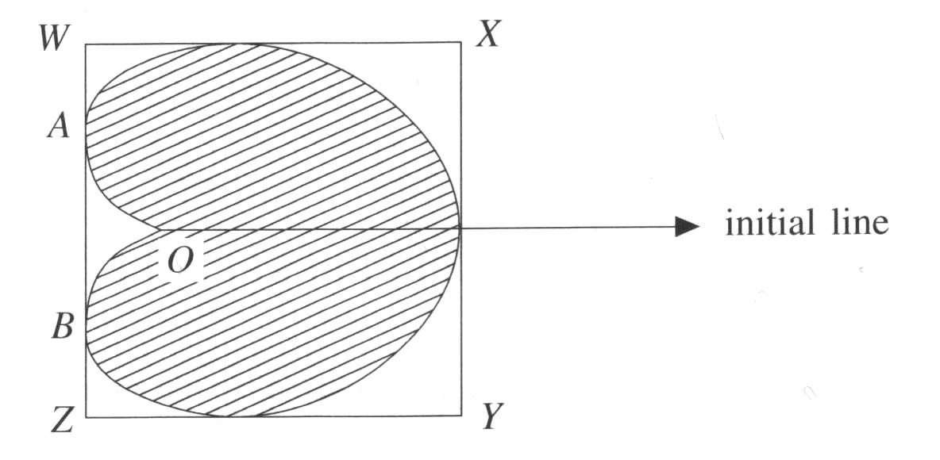

Figure 1 shows a sketch of the cardioid C with equation r = a(1 + cos θ ), −π < θ ≤ π . Also shown are the tangents to C that are parallel and perpendicular to the initial line. These tangents form a rectangle WXYZ.

(a) Find the area of the finite region, shaded in Fig. 1, bounded by the curve C.
(6)
(b) Find the polar coordinates of the points A and B where WZ touches the curve C.
(5)
(c) Hence find the length of WX.
(2)

Given that the length of WZ is $\frac{3\sqrt{3}a}{2}$,

(d) find the area of the rectangle WXYZ.
(1)

A heart-shape is modelled by the cardioid C, where a = 10 cm. The heart shape is cut from the rectangular card WXYZ, shown in Fig. 1.

(e) Find a numerical value for the area of card wasted in making this heart shape.
(2)

END

