4. Projectile Motion

From Unit 2:

A football of mass 500g is kicked so that it sets off horizontally across a flat field with a velocity 10ms⁻¹.

Describe what happens:

What other measures could we find?

What assumptions are we making in order to model mathematically?

The ball comes to rest 25 seconds later.

How far did the ball travel?

What is the magnitude of the constant resistive force acting on the ball?

What if the ball was kicked so that it sets off vertically from a point 1m above the ground with a velocity of 10ms⁻¹.

Describe what happens:

What other measures could we find?

What assumptions are we making in order to model mathematically?

How long was the ball in the air for?

What was the maximum height of the ball?

Unit 4:

Now the ball is kicked so that it sets off horizontally from a point 1m above the ground with a velocity 10ms⁻¹.

Describe what happens:

What other measures could we find?

What assumptions are we making in order to model mathematically?

In order to investigate the motion of a projectile, the horizontal and vertical motions should be considered separately.

The horizontal velocity of a projectile is constant since there is never any acceleration in the horizontal direction.

The vertical velocity on the other hand is subject to the acceleration due to gravity, and the equations of motion can be applied.

These problems are often represented using i and j, the unit vectors in a horizontal and vertical direction.

eg1 A particle is projected horizontally at 10 ms⁻¹ from a point 1m above a horizontal surface. Find the time taken by the particle to reach the surface and the horizontal distance travelled.

eg2 A particle is projected horizontally with a speed of 14.7 ms⁻¹. Find the horizontal and vertical displacements of the particle from the point of projection, after 2 seconds. Find also how far the particle then is from the point of projection.

eg3 A particle is projected horizontally from a point 44.1 m above a horizontal plane. The particle hits the plane at a point which is, horizontally, 39 m from the point of projection. Find the initial speed of the particle.

eg4 A particle is projected horizontally with a velocity of 39.2 ms⁻¹. Find the horizontal and vertical components of the velocity of the particle 3 seconds after projection. Find also, the speed and direction of motion of the particle at this time.

Exercise 4.1 Evens (except Q8 & 14)

Exercise 4.1

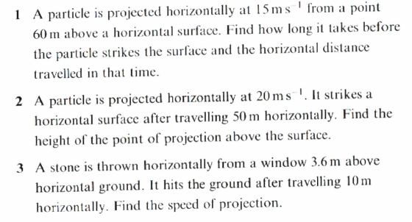

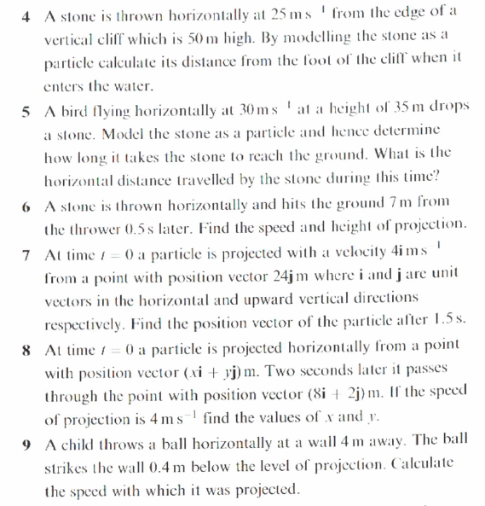

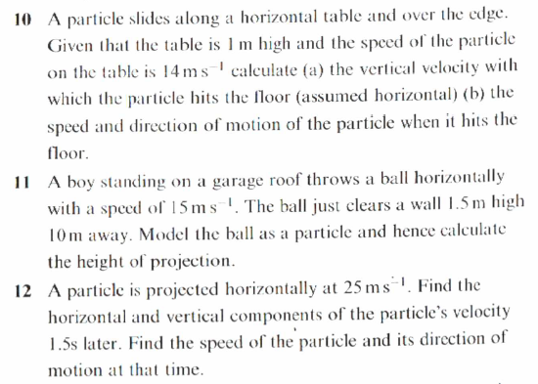

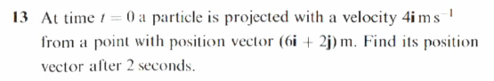

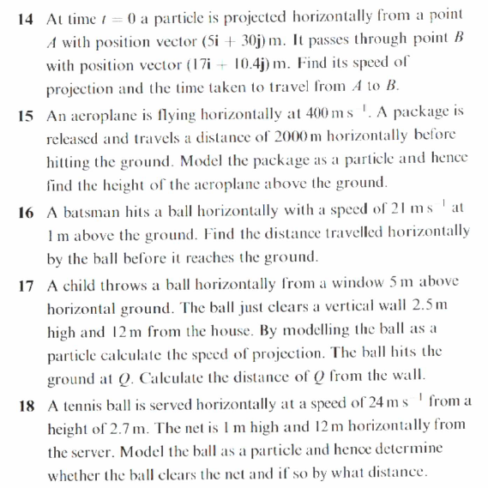

Numerical Answers
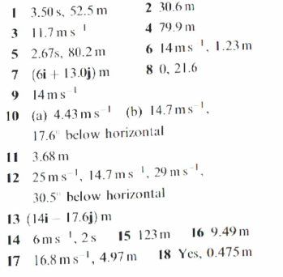

eg5 At time t = 0 a particle is projected with a velocity of 2i ms⁻¹ from a point with position vector
(10i + 90j) m. Find the position vector of the particle when t = 4s.

Exercise 4.1 Q’s 7, 8, 13, 14

Particles projected at an angle to the horizontal

Suppose a particle is projected at an angle θº above the horizontal with a velocity Ums⁻¹.

As before, in order to model the trajectory of the particle, we must consider the horizontal and vertical motion of the particle separately.

This requires us to split the initial velocity into its horizontal and vertical components:

The analysis can then proceed as before.

Eg6 A particle P is projected from a point O on a horizontal plane with speed 28ms⁻¹ and with angle of elevation 30º. After projection, the particle moves freely under gravity until it strikes the plane at a point A. Find
- the greatest height above the plane reached by P
- the time of flight of P
- the distance OA

Eg7 A particle is projected from a point O with speed V ms⁻¹ and at an angle of elevation θ, where $\tan{θ=\frac{4}{3}}$. The point O is 42.5m above a horizontal plane. The particle strikes the plane, at a point A, 5 seconds after it is projected.
- Show that V = 20
- Find the distance OA

Eg8 A particle is projected from a point O with speed 35ms⁻¹ at an angle of elevation of 30º. The particle moves freely under gravity.
Find the length of time for which the particle is 15m or more above O.

Eg9 A particle is projected from a point with speed u at an angle of elevation α and moves freely under gravity. When the particle has moved a horizontal distance x, its height above the point of projection is y.
- Show that $y=x\tan{∝}- \frac{gx^{2}}{2u^{2}}(1+\tan^{2}∝)$
A particle is projected from a point A on a horizontal plane, with speed 28ms⁻¹ at an angle of elevation α. The particle passes through a point B, which is at a horizontal distance of 32m from A and at a height of 8m above the plane.
- Find the two possible values of α, giving your answers correct to the nearest degree.

Eg10 A ball is struck by a racket at a point A which is 2m above horizontal ground. Immediately after being struck, the ball has velocity (5i + 8j)ms⁻¹. After being struck, the ball travels freely under gravity until it strikes the ground at a point B. Find
- the greatest height above the ground reached by the ball
- the speed of the ball as it reaches B
- the angle the velocity of the ball makes with the ground as the ball reaches B.

Exercise 4.2
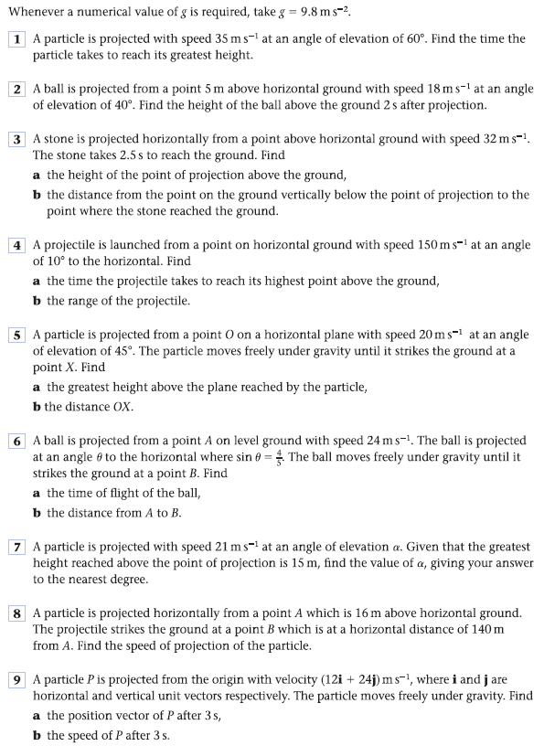
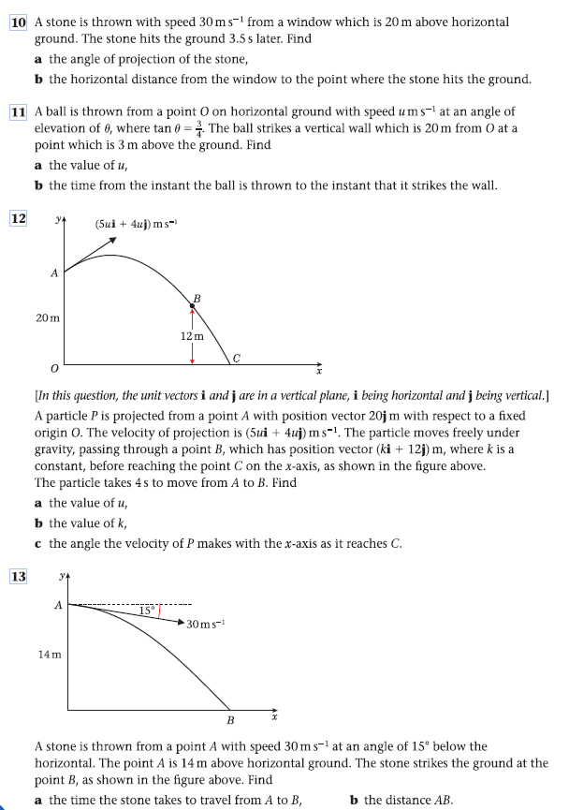

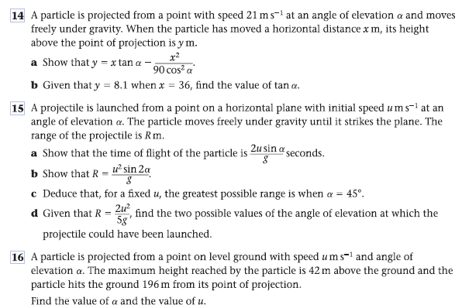

Numerical Answers
