**7. More on Equilibrium & Moments**

**Equilibrium**

* When the resultant of a system of forces acting on a particle is zero, the particle is said to be in equilibrium.
* A particle which isn’t accelerating, but is travelling with a constant velocity is in equilibrium. ie a particle doesn’t have to be stationary to be in equilibrium.
* A particle on the point of moving when the frictional force opposing motion reaches its maximum possible magnitude is said to be at limiting equilibrium.
* When a system is in equilibrium, each part of the system is in equilibrium

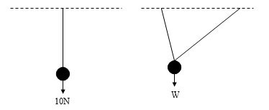

**Eg1** A string is tied to two points on the same level and a ***smooth ring*** of weight 10N which can slide freely along the string is pulled by a horizontal force, *P*. For the position of equilibrium shown in the diagram, find *P* and the tension in the string.

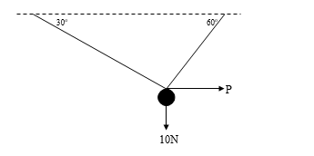

**Eg2** ABCD is a string knotted at B and C. Find W and the tensions in AB, BC and CD.

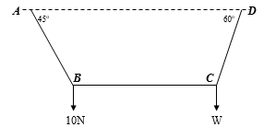

**Eg3** The diagram shows a sign attached to a point A. It is supported by two light rods AB and AC.

The rod AC is horizontal and the rod AB is at an angle of α to the horizontal, where sin α = 0.6.

The mass of the sign is 12kg.

Calculate the forces acting along each rod, indicating clearly whether the rods are in thrust or tension.

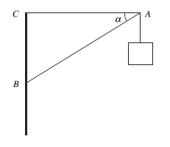

**xercise 7.1 (WJEC PPs)**

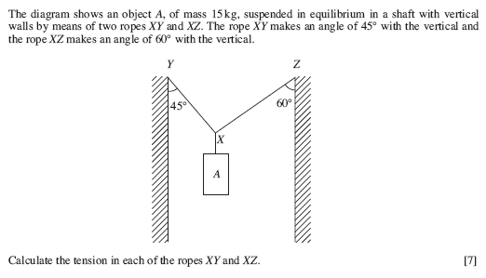

1.

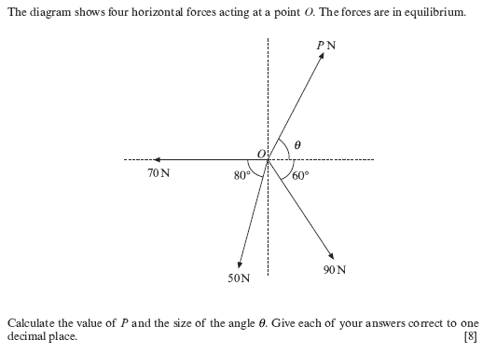

**2.**

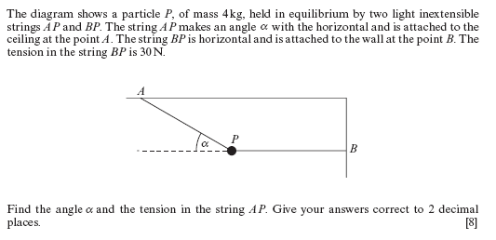**3.**

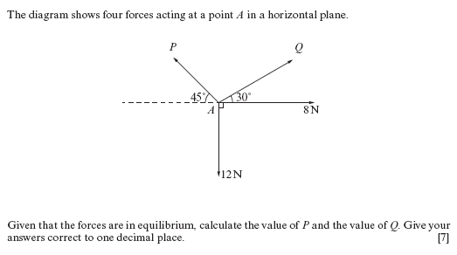

**4.**

**Answers**

1. 131.8N, 107.6N

2. P = 131.6N, θ = 75.2o

3. T = 49.2N, α = 52.6o

4. P = 14.9N, Q = 2.9N

**The Moment of a Force**

From our everyday experience we know that:

* it is easier to undo a tight nut using a long spanner when the force is applied to the end of the spanner, rather than by using a short spanner.
* If a boy sits at one end of a see-saw which is pivoted at its centre, he can be balanced by a heavier boy sitting nearer to the centre of the see-saw.
* A door is more easily closed by pushing on the edge further from the hinges, rather than by pushing at a point part way across the door.

In each of these examples, the application of the force is causing a body to rotate about an axis, ie rotational motion. Previously, only motion along a line has been considered, ie translational motion.

**Definition**

The moment of a force about a point is found by multiplying the magnitude of the force by the perpendicular distance from the point to the line of action of the force.

P

***The moment of the force P about the point X is ***

X

d

A force will have no moment about a point on its line of action as d = 0.

If the force is measured in Newtons and the distance in metres, the moment of the force is measured in Newton metres (Nm).

**Sense of Rotation**

A nut is usually rotated in an anticlockwise direction when being undone. All rotations should have their sense clearly stated (eg, +ve clockwise, -ve anticlockwise): the moment of a force about a point has both magnitude and direction.

**Algebraic Sum of Moments**

If a number of coplanar forces act on a body, their moments about any point may be added provided due regard is given to the sense of each moment.

**Eg4** For each of the situations below, find the total moment about the point A.



**Exercise 7.2**

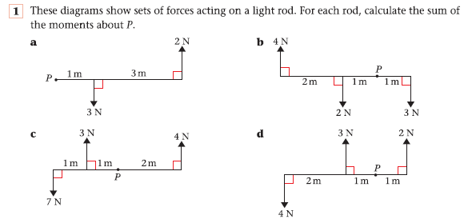

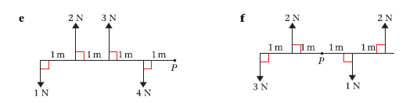

**Ex 7.2 Answers**

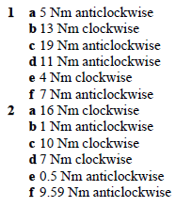

**Ex 7.2 Answers**



**Parallel Forces in Equilibrium**

For parallel forces to be in equilibrium, two conditions must hold true:

1. the component of the resultant force in any direction must be zero,
2. the algebraic sum of the moments about any point must be zero, ie the sum of the anti-clockwise moments must equal the sum of the clockwise moments.

**Eg5** A uniform beam, of length 2m and mass 4kg, has a mass of 3kg attached at one end and a mass of 1kg attached at the other end. Find the position of the support if the beam rests in a horizontal position.

**Eg6** A light horizontal beam of length 2m rests with ends A and B on smooth supports. The beam carries masses of 5kg and 2kg at distances of 60cm and 150cm respectively from A. Find the reaction at each support.

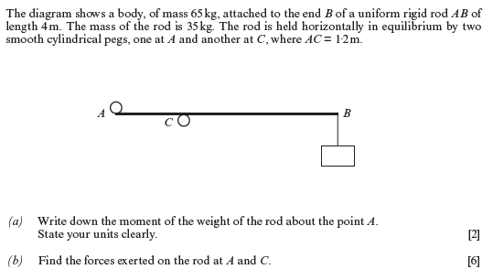

**Eg7**

**Non-Uniform Rods (rod – assumes no thickness and no bending)**

The centre of mass of a non-uniform rod is located at some point other than the midpoint of the rod.

**Eg8** A non-uniform rod AB of length 4m and mass 5kg is in equilibrium in a horizontal position resting on two supports at points C and D where AC = 1m and AD = 2m. The magnitude of the reaction at C is half the magnitude of the reaction at D. Find the distance of the centre of mass of the rod from A.

**Exercise 7.3 (WJEC PPs)**

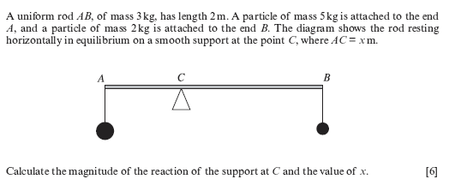

1.

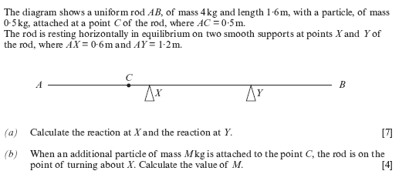

2.

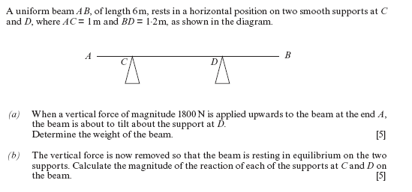

3.

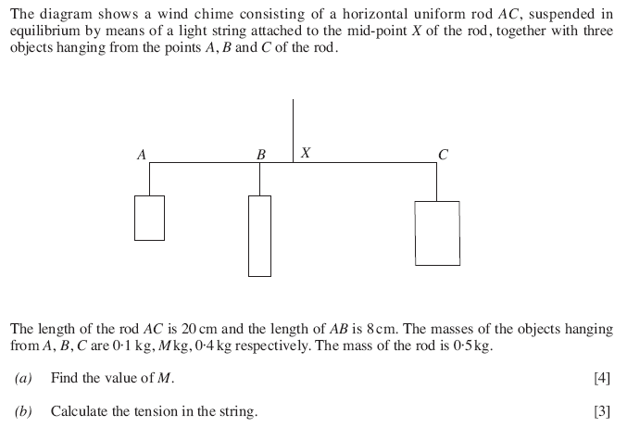

4.

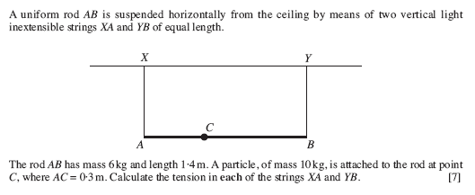

5.

**Answers**

1. R = 98N, x = 0.7m

2. Rx = 31.9N, Ry = 12.3N, M = 7.5kg

3. W = 4800 N, Rc = 2274 N, RD = 2526 N

4. M = 1.5 kg, T = 24.5 N

5. TA = 106.4 N, TB = 50.4 N