Unit 3 – Proof
In mathematics it is tempting on the basis of checking a number of special cases to deduce that a general conjecture is true.
Consider the function $f\left(n\right)= n^{3}-4n^{2}+7n+$1, where n is a positive integer.
f(1) = 5
f(2) = 7
f(3) = 13
f(4) = 29
f(5) = 61
all of these numbers are primes.
A possible conjecture would therefore be that when n is an integer, $n^{3}-4n^{2}+7n+1$ is a prime.
However, although this conjecture is true for n = 1, 2, 3, 4, 5 it may not be true for all integer values.
Indeed f(6) = 115, which is not prime.
A correct proof is the only way to convince another of the truth of a conjecture. There are a number of methods of proof.
In A level, you will have met examples of direct proof such as the sums of arithmetic and geometric series. Other methods of proof include mathematical induction and disproof by counter-example (which is what f(6) achieves above). In Unit 3, we focus on proof by contradiction.
Proof by Contradiction
Proof is concerned with the demonstration of the truth of an assertion. The essence of proof by contradiction is to assume the assertion is false and show that the assumption leads to a contradiction.
Eg1 Prove that if n² is even, then n is even
Eg2 Prove that $\sqrt{2}$ is irrational
Eg3 Use a proof by contradiction to show that if a and b are real numbers, then $a^{2}+b^{2}≥2ab$
Eg4 Prove by contradiction that if x is real and x > 0 then $x+\frac{4}{x}≥4$
Eg5 Prove that there is an infinite amount of prime numbers

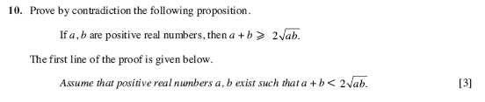
Exercise (WJEC PPQs)
1.

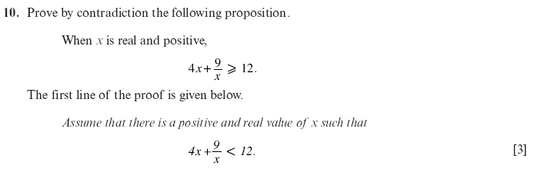
2.

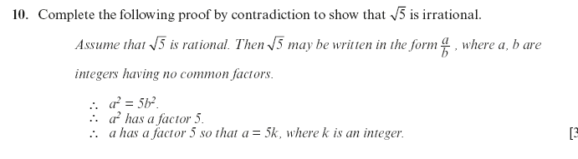
3.

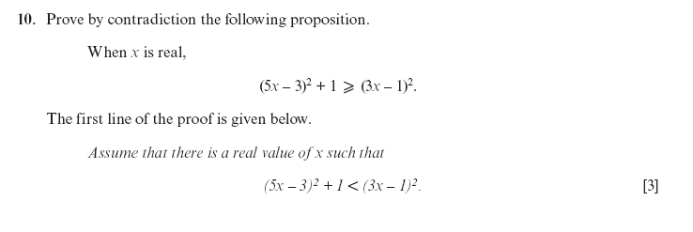
4.

